Alexander Reese

Yan Huang

SWE 6623

Final Project Report

**Idea**

I wanted to create a software that can help user get a better control over their buying and security. The importance of the software is for anyone who can be forgetful or is compulsively buying items. It can also help people who wants extra security for their purchases and help manage what items they own and want to purchase. This software can be used to help users save money find or keep track of old product they probably own that is held in their storage. I wanted to create a solution that can help people not only save money and time, but also add extra security when it comes to online purchases through the web.

**Plan& Manage**

In terms of the planning phase, I started this project in the beginning of the semester and planned to finish it by the end of the semester. The first step was all about how the project was going to run, what language was going to be used to run the program and finding the requirements for the software. When it came to scheduling, I created an estimated time on how long the project will take and when it will be completed. Table

Fig 1.

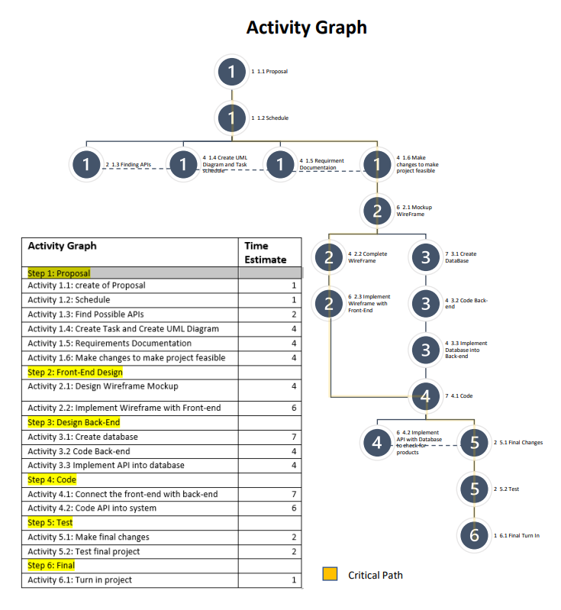Fig 2.

In figure 1 and 2, this is the schedule and activity graph that shows the estimate amount of days it could take to complete the project. Sadly, there were a lot of setbacks due to other important matters and deadlines. There was also a feasibility issue with the project which was the lack of understanding on how to properly code and program the software. I did not properly scope the project correctly and later realized the difficulty of the project I was building. I managed the project by working on it every week in the semester. A lot of changes have occurred from the development of the project to the later stages of development to make the project easier to build. I manage to change how the product can be stored in a database and to make the simplicity sake for the project, I decided to drop the security portion of the project.

**Requirements**

The requirements of the proposed project will influence on how the project will run and hopefully prevent failure. The requirement of the project will be listed below

1. The program must be able to take new user accounts
2. The program must be able to take multiple order request
3. The program must be able to run while both child and parent account is active
4. The program must be able to have updatable order details and shipping info.
5. The program must be able to have an updatable database
6. The user must be able to manually interact with their database so they can make edits.
7. The user must be able to interact the gate to stop or proceed with purchases
8. The program must be able to allow users to update their information
9. The program must be able to take orders and send them to the gate in evaluation to go into the database

Fig 3.

In figure 3, This is the UML diagram for the proposed project, The UML shows how the classes and objects react to each other with their methods.

Regarding the user interface, the plan was to use Java GUI to be able to interact with the gate and interact with the database.

1. User Interface
   1. a. Pop-up to inform with users about items in user database
   2. b. Navigation to see User’s database
   3. c. Yes/No pop-up for approval of purchases
   4. d. Security and notification customization
   5. Navigation to manipulate with the database

**Architecture**

The architecture style I decided to use was the Layered Style. I felt the layered style was the best style to represent my project as it shows how the project will need to access different tiers to make purchases to enter the product into their database.

fig 4.

In figure 4, it shows how the layered style plays into action. The user will be given a Database they can customize and manage which is linked to the application. As the user browses the web and tries to make the purchase off the store’s inventory, the application will check the user’s data base and check for item similar in that category. The user must make an option to proceed or decline the purchase.

**Difficulties**

There was a lot of difficulties when working on this project. With no background in programming and software development, I understood on the project managing side of things, but when it comes to coding and developing the project, I struggled the most in that criteria. I made a lot of last-minute changes on how the user will be able to access the database and how they can interact with it. When it came to testing the project a lot of the time the file would not update when the user completed their “purchase”. I also encountered a lot of loops when it came to allowing the user to choose which product, they wanted to put into their database which made is more frustrating for me to figure out. I was able to get a couple of the functions and features completed but was not able to complete the project. I learned a lot while building the program and I was close to completing the project, but in the end, I did not get what I wanted to accomplish.

**Deploy**

I deployed the project to my GitHub (<https://github.com/areese30/Final-Project-6623.git>), but if the project would to be deployed as a real-world application. It would be used as a third-part application to assist with large database store websites like amazon, Walmart, Target, etc. This application could also be used as an API so when a purchase is made, the purchase goes to the database and is stored automatically.

**Quality of developed project & measurement result**

For me to explain the quality of the developed project, if it were completed it would be 6 stars out of 10 if it was on a scale rating system. I would measure it on completeness, use of current technology, and if it were able to handle to problem it wanted to handle. The project is not complete so this will hurt t quality. The project uses old techniques to handle database and data which is not secure. Lastly, even though it can be used to handle the task it is meant to tackle, there are better techniques to create a better project. I believe it could have handled it better, but due to time constraints and limited knowledge, the quality of the developed project is much lower than the goal, in its current state the quality of the product is a 3 out of 10.